Adjutant Desktop ODBC Connection Setup Instructions

Version 1.0
Sep 15, 2011

Using the ODBC Data Source Tool

Normally found in the Administrative Tools folder

64Bit Note
If 64bit OS, the 32bit version of the ODBC Tool must be used, it can be found in the
sysWOW64 folder in the windows root folder. It is named odbcad32.exe

Add a New Data Source (Using the System DSN Tab)

Click on Add

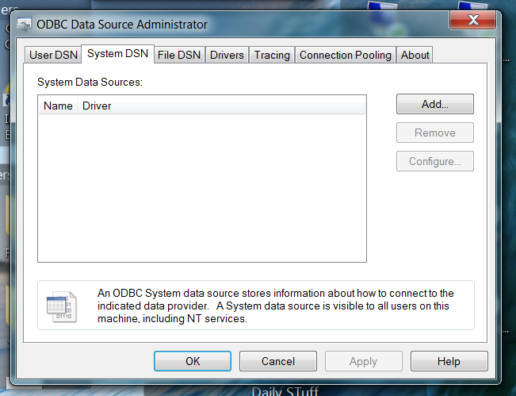

Select the SQL Native Client (2005.9 version)

Clients can be downloaded from here if not installed.

https://www.microsoft.com/en-us/download/details.aspx?id=17943

sqlncli.msi for 32bit OS

sqlncli_x64.msi for 64bit OS

Adjutant Does Not work with the 10.0 version

Click on Finish

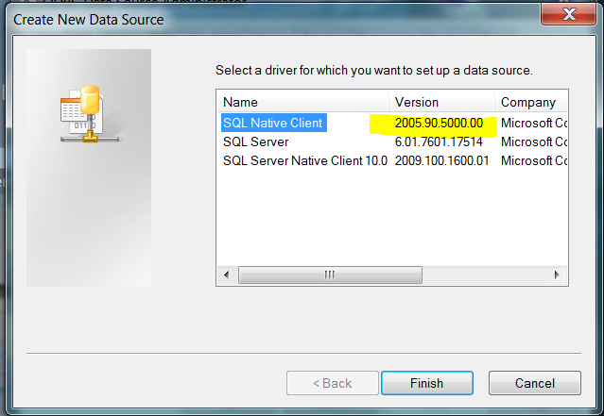

Fill out the first page of the wizard

Name: This name varies by install, but is the first line in the cstring.txt file in the adjutant folder.

Description: Does not matter, can be anything.

Server: Select the SQL Server the Adjutant database is installed on. The server should be in list, but if not, it can be typed in. If the server is not running as an instance, then just type in the server name. If running as an instance, then type in the server name\instance name.

Click on Next

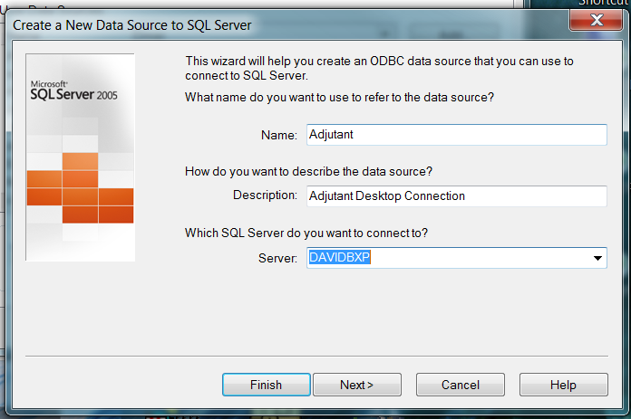

Setup Security

If SQL server is using Mixed Mode authentication (Most Adjutant Installs do)

Select With SQL Server authentication radio button

Check the Connect to SQL Server box

Enter the SQL Adjutant user and password. For most installs, it is adjuser1 and adj1. These values are the second and third lines in the csting.txt file in the Adjutant folder.

If using Windows Authentication,

Select the With Integrated Windows radio button

Click on Next

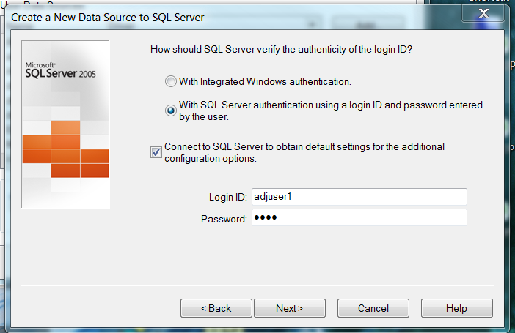

Check the Change the default database to:

Select the adjutant database from the list, if not in the list, it can by typed in, standard name is adjutant, some installs are different.

Click on Next

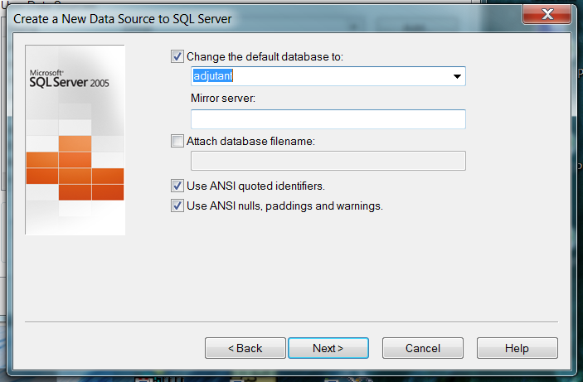

The defaults are fine on this tab.

Just click on Finish

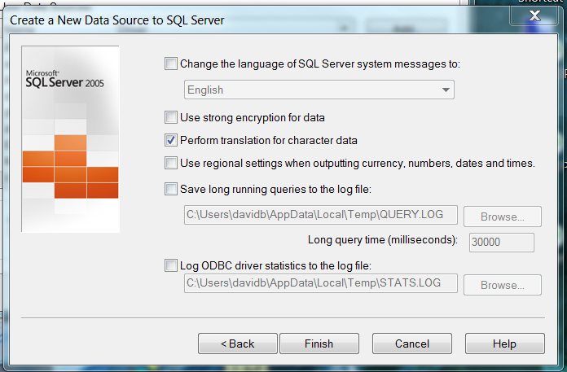

The Test page will appear.

Clicking on Test Data Source will verify the setup is good.

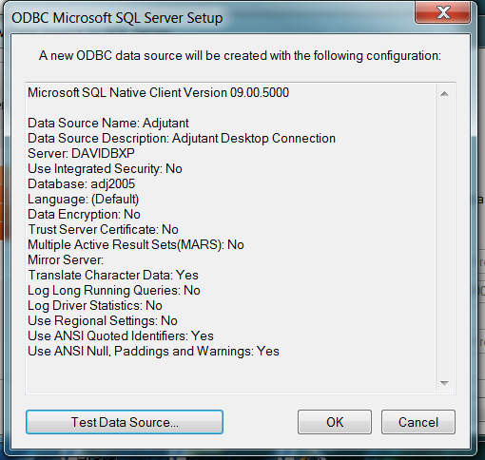
Good Test Results

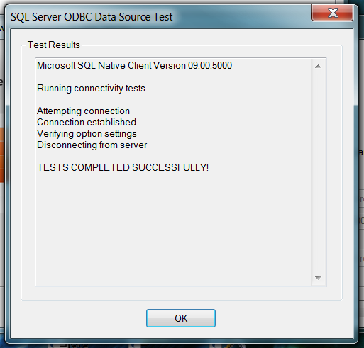

Clicking on OK returns to previous screen, click on OK to create data source

